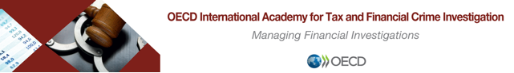

International Cooperation, Scenario Final Exercise

PART III

In addition to what you already know from PART I & II, you learn / obtain the following information:

- As a result of your requests for assistance / information abroad, you obtained incorporation records from the BVI and subscriber information from the US. The information includes, inter alia, the following:

  - The incorporation records for KARUPPED CO show that the sole shareholder of the company is Tom BORDER. The copy of the incorporation application provided includes a copy of a page of BORDER’S passport. The passport page includes: citizenship (USA), date of birth (03/10/1975) and a picture.

  - The subscriber (client) for IP 123.456.789 and phone number 518-444-3254 is Tom BORDER, with an address in Champlain, New York, USA.

- The account holder for account #987654 with the Bank of Bahamas is Tom BORDEN born 10/03/1975. There is currently USD$1M in the account and the funds are all coming from account # 456789 with VP Bank (BVI) Ltd, in the British Virgin Islands.

- You looked up online “Tom BORDER”. You found a LinkedIn profile under that name, with a picture. In the “experience” section of the profile, it shows that BORDER has been an officer with the US Customs and Border Protection since August 2019, and still is. In your opinion, the male in the profile picture is about 40-50 years old and looks a lot like the male in the passport page provided with KARUPPED CO’s incorporation application.

QUESTION:

- Based on the new information obtained (above), what are the next steps in you investigation?

