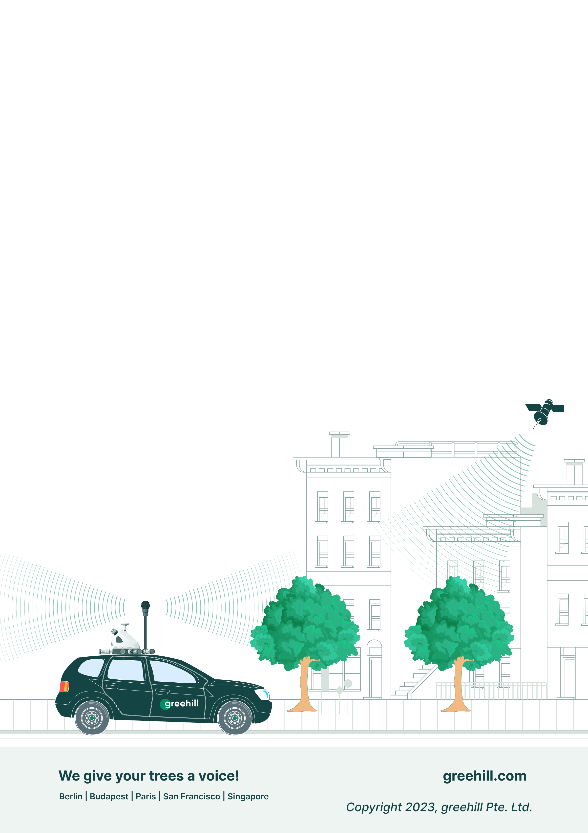

Tree Monitoring
Standard (TMS)
  - OCTOBER 2023

Table of Contents
Introduction 3
Definition of a Tree 3
The Tree Test 3
greehill Tree Monitoring Standard 4
Definition of “Tree” 4
Planting Arrangements 5
Symmetrical Planting Arrangement (SPA) 5
Occlusions 5
greehill Level of Information System 6
Levels of Information 6
Information for each LOI 7
Examples 9
Annex 1: What is a Tree? 10
Single Woody Stem 10
Definite Crown Shape 10
Secondary Growth 10
Height 10
Exceptions 11
Shrubs 11
Annex 2: Planting Arrangements 12
Symmetrical Planting Arrangement 12
Asymmetrical Planting Arrangement (Natural Areas) 12

Introduction
greehill is a tech company specialized in urban tree monitoring that offers a wide range of services for the care and maintenance of trees in urban and suburban areas. Our Company Standard for Urban Forestry Management is a commitment to promoting the health and resilience of urban trees through best practices and sustainable management. As a company, we understand the critical role that trees play in urban ecosystems, and we prioritize the long-term health and vitality of urban trees while taking into account their impact on citizens.

Definition of a Tree
In our industry, it is important to have a clear and comprehensive definition of a tree. While the botanical definition is relevant, urban tree management must also consider two additional important aspects:
- The human element – we believe that our definition must incorporate plants that look like trees but may not be botanically classified as such.
- The authorities – given the importance of tree management for public safety, it is critical that our definition of a tree considers plants that serve a similar function in the urban environment but may not be botanically classified as trees. Such plants can still be hazardous to citizens and infrastructure, and we believe that it is our responsibility as a company to consider their impact when managing urban trees.

The Tree Test
The ‘duck test’ is a type of argument in which an unknown object can be identified by its habitual characteristics. It is used to counter arguments that something isn’t what it seems. Similarly, greehill has developed The Tree Test (TTT) to identify plants that may not be classified as trees but appear as such to a lay person. This methodology provides a standardized way to classify urban trees, ensuring a comprehensive and reliable service for our clients. Examples of such plants include palm trees, bamboo, banana trees and some shrubs that resemble trees.

greehill Tree Monitoring Standard
The following definition of a Single Tree according to the greehill Tree Monitoring Standard (TMS) has been developed in collaboration with Prof. Steffen Rust.

Definition of “Tree”
Any plant meeting at least one of the criteria below is considered a Tree:
 | Height: Any plant that is more than five meters high and has a woody stem. Exception to this rule are plants like herbaceous or woody climbers which will not be included.
 | Single-stem Tree: Any plant with a trunk that is at least one meter tall or at least five centimeters in diameter.
 | Multi-stem Tree: Any plant with multiple trunks of at least one meter clearance from the ground is considered a single tree if the trunks are joined at their base or the distance between the trunks is less than 0.5 meters.
 | Crown: Any plant that has a “Distinct Elevated Crown” (DEC).
 | Columnar Shaped Tree: Any tree with a column-like appearance and at least 1 meter in height, such as columnar trees, broad-leaf trees, cypress, etc.
 | Palms and Banana Trees: All palms and banana trees with a trunk height of at least one meter and a trunk diameter of at least five centimeters, are considered trees in the greehill TMS (even though they are not considered as trees from a botanical standpoint).
 | Stakes: Supporting poles indicate that a plant is intended to be grown as a tree and will therefore be included in the greehill TMS regardless of the plant's height and stem diameter.
 | Trees in Boxes: Despite being in a ‘movable’ object, any plant planted in a box is considered a tree if it meets at least one of the criteria above.

greehill TMS can also detect tree remains but with limited information:
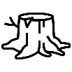  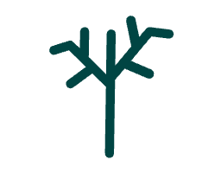 | Dead / topped Trees: Dead / topped trees are also considered Single Trees if they meet at least one of the criteria above.  Tree Stumps or other Tree Debris: After a tree has been cut and felled, the small remaining portion of the trunk is considered as tree in the greehill TMS, if it is more than 30 cm in height.

Planting Arrangements
A planting arrangement refers to the pattern or layout in which plants are positioned when they are planted in a specific area. This includes the spacing between individual plants and the orientation of the plants, among other factors.
Understanding different planting arrangements is crucial when dealing with multiple trees. These arrangements have a significant impact on the company's ability to identify and differentiate individual trees from each other and affect the accuracy of the information provided for each tree.
In greehill TMS, we differentiate between two types of planting arrangements: Symmetrical and Asymmetrical.

Symmetrical Planting Arrangement (SPA)

Symmetrical Planting Arrangement is a planting pattern in which plants are arranged in a balanced, evenly spaced, and uniform manner on either side of a central axis or along a straight line. In this arrangement, the plants are positioned equidistant from each other on either side of the axis. Examples of such arrangements include rows, avenues, grids, quincunx, groves, etc.

Natural Area: Asymmetrical Planting Arrangement (APA)

Asymmetrical Planting Arrangement, can also be identified as a natural area, is a planting pattern in which plants are arranged in an irregular, non-uniform manner. It is the opposite of a symmetrical planting arrangement and is often used to create a more natural or organic look in a landscape design. Examples of such arrangements are copses, woods, forests, etc. A planting arrangement is considered by the greehill TMS as an APA under the condition that at least one trunk of at least one-meter-height is visible.

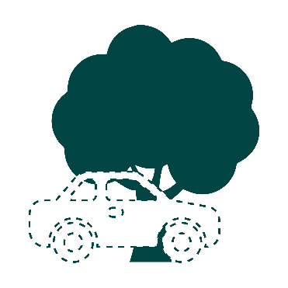
Occlusions
An occluded tree is a tree that is partially or completely obscured by other objects or obstructions in its surroundings. This can be caused by "understory vegetation" or by physical objects in front of the tree, such as a car, fence, or another tree.
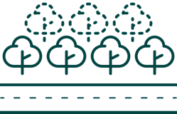
“Understory vegetation” is the layer of plants, including trees, shrubs, and herbaceous plants, that grows between the ground and the canopy.
In greehill TMS a plant is considered “occluded” if a significant portion of it is not visible. Trees in greehill TMS are classified based on their occlusion severity, which results in different level of Information as described in the next section.

greehill Level of Information System
greehill is dedicated to helping cities manage their urban trees inventory and we recognize the importance of gathering as much information as possible about each urban tree.
Extracting detailed information about each tree in the urban environment can be challenging. For example, part of a tree might be obscured by vehicles or fences, or dense clumps of vegetation may contain a variety of different plants.
Despite these challenges, we are committed to providing as much information as possible for each Single Tree and Planting Arrangement. This is why we have introduced the greehill Level of Information (LOI) system, which consists of four levels of information and describes in detail the level of information provided in different scenarios.

Levels of Information
The greehill TMS categorizes information into four different levels, which we refer to as "Level of Information" (LOI).
- Level 0 (L0): L0 is applied to a Single Tree or to each tree in a SPA, under the conditions that at least 1 meter of trunk is visible, and the crown is visible. L0 provides all available information with high accuracy.
- Level 1 (L1): L1 is applied to a single Tree or to each tree in a SPA, under the conditions that less than 1 meter of trunk is visible due to understory vegetation and the crown is visible. In this case we provide estimated information about the trunk and accurate information about the canopy.
- Level 2 (L2): L2 is applied to a single Tree or to each tree in a SPA and APA, under the conditions that more than 1 meter of trunk is visible, and the crown is not visible or cannot be separated from its environment. In this case we provide accurate information about the trunk, and estimated information about the canopy.
Exceptions to this LOI are dead trees and stumps, in this case we will not provide information about the canopy and / or the trunk.
- Level 3 (L3): L3 is applied under the following conditions: A plant is more than 3 meters high, less than 1 meter of trunk is visible, and the crown is not visible. This case is referred to as "High Vegetation". In such cases, we provide the position of the High Vegetation, its width, height, and estimated ecosystem services (ESS) parameters.

Information for each LOI
The following figure LOIs Metrics summarizes the information and metrics included in each LOI.
Glossary:
- ST: Single Tree
- SPA: Symmetrical Planting Arrangement
- APA: A-symmetrical Planting Arrangement (natural area)

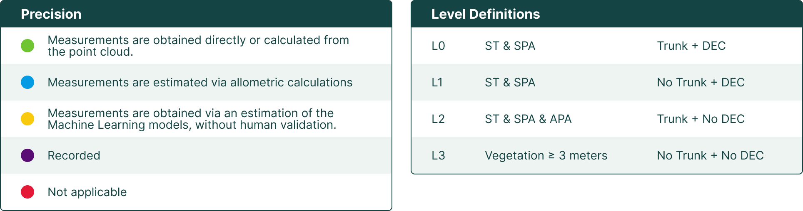

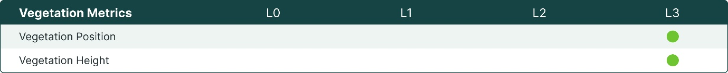
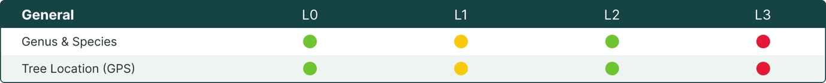
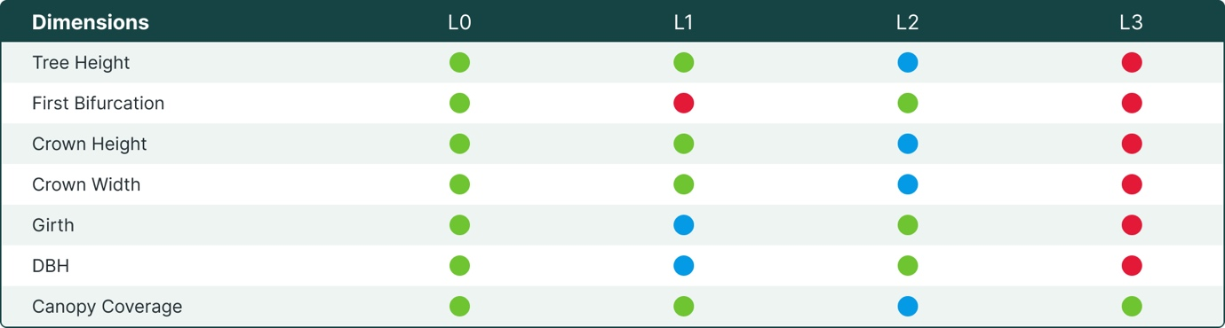
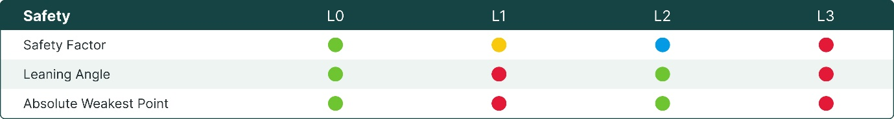
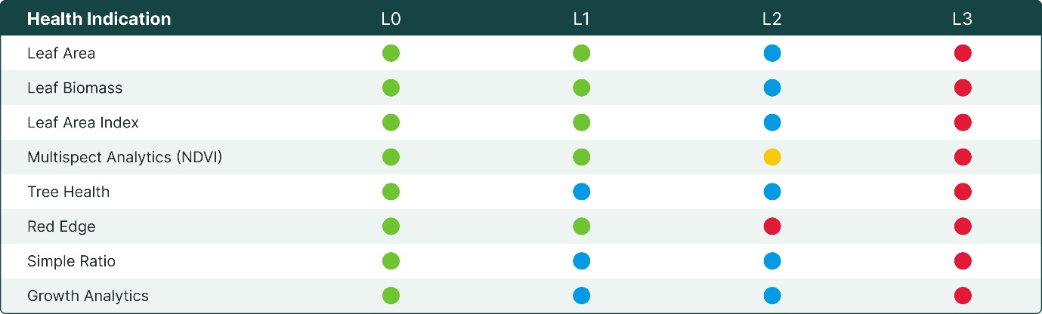
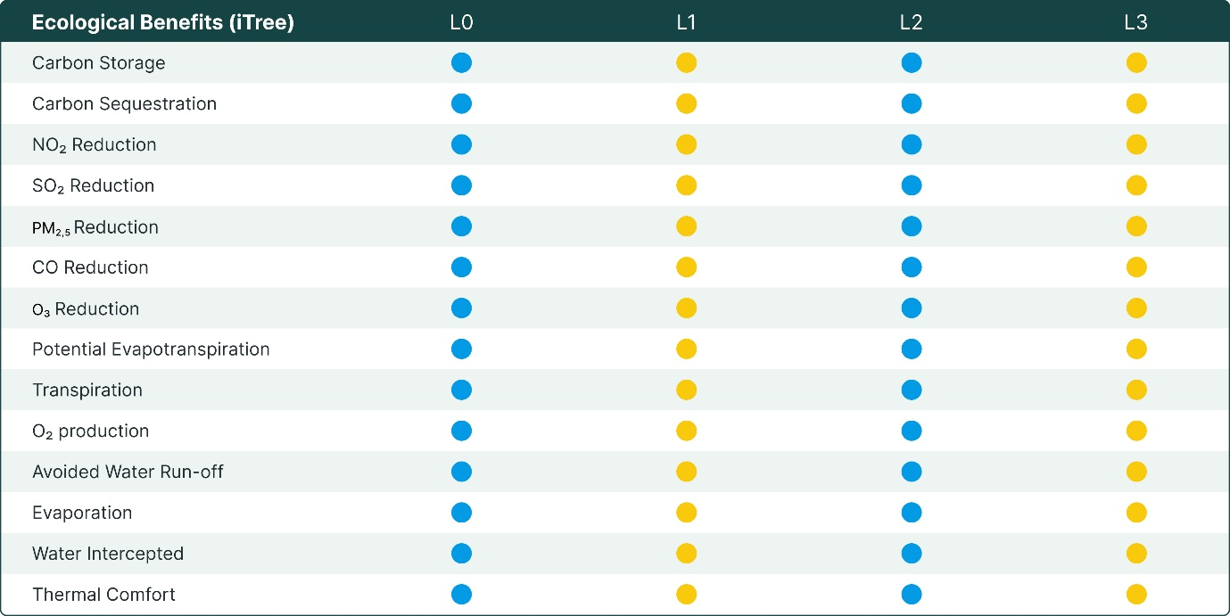
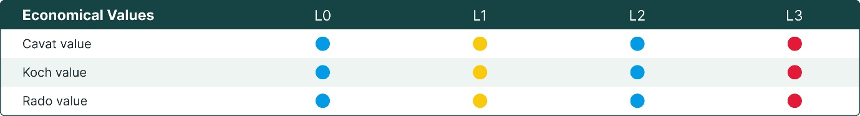
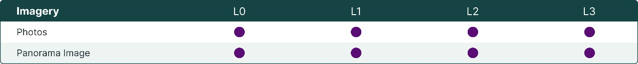

Examples
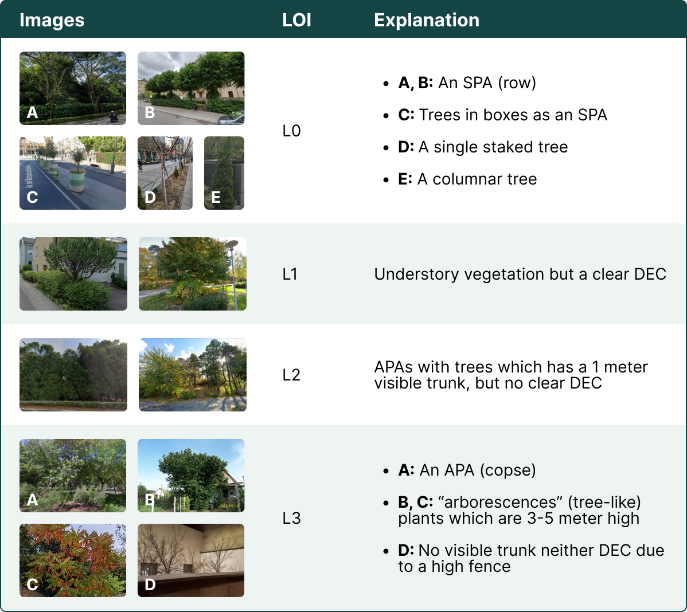

Annex 1: What is a Tree?
From a botanical perspective, trees are defined as perennial plants with a single main stem or trunk that possess the ability to produce wood and bark, as well as undergo secondary growth. They are typically taller than shrubs and other non-tree plants, and their strength and support are due to their woody stems and extensive root systems.

Single Woody Stem
From a botanical perspective, trees are defined as perennial plants that possess a single main stem or trunk, which grows continuously through the activity of apical meristems. These meristems are responsible for producing new cells that differentiate into primary tissues, such as leaves, branches, and flowers. Trees are further distinguished by their ability to produce wood, which provides structural support and stability, as well as bark, which protects the inner tissues from damage and disease.

Definite Crown Shape
A distinct crown is a recognizable growth pattern in which the upper branches and foliage of a tree are concentrated towards the top, resulting in a well-defined and elevated crown. This growth pattern is typical of many tree species and is a defining characteristic of trees. Unlike many plants, trees have a single main stem or trunk that branches out near the top to form a canopy or crown. The shape of the crown varies greatly among different species of trees and is a key characteristic used for their identification.

Secondary Growth
Trees are also characterized by their secondary growth, which allows them to grow in diameter and height over time. This is achieved through the activity of lateral meristems, which produce new cells that differentiate into secondary tissues, such as wood and bark. This secondary growth is one of the most distinctive features of trees, setting them apart from other perennial plants.

Height
Furthermore, trees are typically taller than shrubs and other non-tree plants, often reaching heights of 5 meters or more. This ability to grow tall and maintain their structure is due to the strength and support provided by their woody stems and branches, as well as their extensive root systems. These characteristics make trees a critical component of many ecosystems, providing habitat for wildlife, regulating water cycles, and contributing to air quality, among other services.

Exceptions
While trees are generally defined as perennial plants with a single main stem or trunk and the ability to produce wood and bark, there are some plants that are commonly referred to as trees but do not fit this definition from a botanical perspective. Examples of these include palm trees, banana trees, tree ferns, bamboo, and more. These plants may be mistaken for trees due to their height and structure, but they differ in their growth patterns and internal structure. As a company specialized in urban forest management, it is important to recognize these differences and ensure that our services are tailored appropriately to encompass all relevant vegetation in the urban environment.

Shrubs
Shrubs are woody plants that are typically smaller and shorter than trees and are usually less than 3 meters (10 feet) tall. Intermediate between shrubs and trees are ‘arborescences’, or tree-like shrubs, from 3-5 meters tall. Unlike trees, shrubs usually have multiple stems that originate from the base of the plant, and they may have a more rounded or bushy shape. Additionally, while shrubs may produce wood, it is often less dense and less structurally significant than the wood produced by trees.
Shrubs also differ from trees in their growth habits. While trees typically have a single main stem or trunk, which grows continuously, shrubs may grow multiple stems and branches that may not have a clear central leader. Shrubs also tend to have a shorter lifespan than trees, with many species only living for a few decades.
Despite these differences, there is often some overlap between shrubs and trees in terms of their size and growth habits. In some cases, a plant may even be classified as either a small tree or a large shrub, depending on its growth patterns and characteristics.

Annex 2: Planting Arrangements
A planting arrangement refers to the pattern or layout in which plants are positioned when they are planted in a specific area. This includes the spacing between individual plants, the distance between rows, and the orientation or direction of the rows, among other factors.
Understanding the different planting arrangements is crucial when dealing with a group of trees. These arrangements have a significant impact on our ability to identify and differentiate each tree instance and also affect the accuracy of the Level of Information (LOI) provided for each tree.

Symmetrical Planting Arrangement
A Symmetrical Planting Arrangement (SPA) is a planting pattern in which plants are planted in a balanced, evenly spaced, and uniform manner on either side of a central axis or along a straight line. In this arrangement, the plants are positioned equidistant from each other on either side of the axis.
- Avenue trees: Trees planted in a straight line on both sides along a path, street, or driveway to create an attractive vista or provide shade. Trees are typically planted 3-12 meters apart from each other over a minimum distance of 50 meters.
- Tree rows: Trees planted in a straight line, with regular spacing between then, on one side of a path, street, or driveway. Trees are typically planted 3-12 meters apart from each other over a minimum distance of 50 meters.
- Grids: Trees planted in a regular, evenly spaced pattern, forming a geometric grid.
- Clumps: A group of trees or bushes that are planted closely together for ornamental or visual purposes. Clumps are usually comprised of a single species and often arranged in a circular or oval shape to create a visual focal point.
- Groves: A group of trees, typically of the same species, that grow close together, generally without understory or underbrush vegetation. A grove is defined by the number of individuals or the density of the trees within it; they do not generally exceed one acre in size.

Asymmetrical Planting Arrangement (Natural Areas)
An Asymmetrical Planting Arrangement (APA) is a planting pattern in which plants or trees are arranged in an irregular, non-uniform manner. It is the opposite of a symmetrical planting arrangement and is often used to create a more natural or organic look in a landscape design.
- Hedges: A line of closely planted shrubs, trees, or bushes that are trimmed and trained to form a barrier or boundary between two areas. Hedges are typically used for decorative or functional purposes such as privacy, security, or wind protection. Hedges can be made up of a variety of plant species and can be shaped into different forms, such as a formal or informal hedge. They can range in height from a few feet to several meters, depending on their intended purpose and the specific plant species used.

- Copse: A small group of trees or a thicket of bushes growing closely together, typically with a dense and tangled growth pattern. It often implies a dense grouping of trees or bushes that may be too small to be considered a full forest. A copse is generally denser and more tangled than a grove, with less space between the trees. In contrast to clumps, which are usually pruned and shaped to maintain their size and shape, a copse is left to grow naturally.
- Woods: An area of land covered with trees and underbrush, larger than a copse, and smaller than a forest.
- Forests: A large area of trees growing together, often covering a significant portion of the landscape. Forests can be made up of a variety of tree species and can provide important ecosystem services, such as carbon sequestration, watershed protection, and biodiversity conservation.
