Latin America Energy Efficiency Policy Online Training Week

Day 3, Indicators and Evaluation

Self-study session answers

Answers
Activity 1: Course Module 1: Why indicators? A Methodological Framework Lesson 2: IEA pyramidal framework Which are the Priority Sectors in Your Country? - No right answer.
Activity 2: Course Module 1: Why indicators? A Methodological Framework Lesson 2: IEA pyramidal framework Examples of Indicators
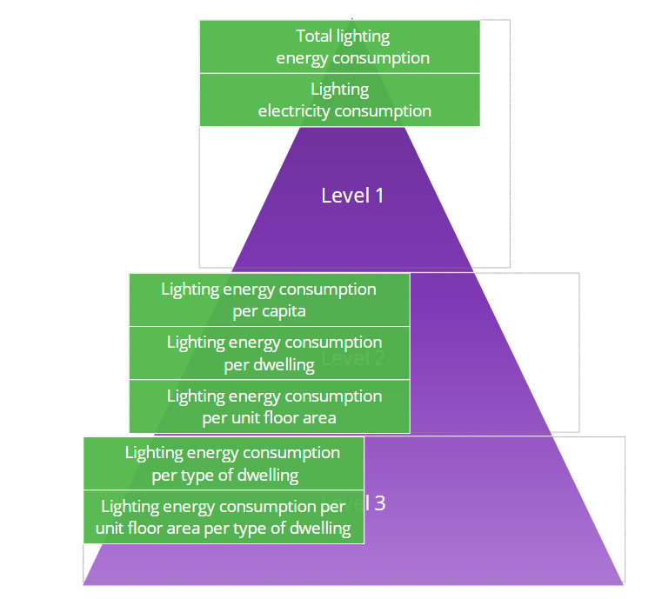
Activity 3: Course Module 1: Why indicators? A Methodological Framework Discussion forum Give us an example from your country - No right answer.
Activity 4: Course Module 1: Why indicators? A Methodological Framework Discussion forum Sources of data in your country - No right answer.
Activity 5: Course Module 1: Why indicators? A Methodological Framework Assessment test

Module 1: Assessment Test

1. Match the concepts with their definitions (examples)
Delivering more services for the same energy input, or the same services for less energy input. Often a function of technological change.
- Energy efficiency improvement
- Energy intensity of the economy
- Energy conservation
2. Why are energy balances insufficient to monitor and assess energy efficiency'? Select all that apply.
They do not show detailed energy data within economic sectors
They do not account for the impact of various factors (e.g. technological, behavioural) of energy consumption
They give data on the energy entering, exiting and consumed in a country but not on the way it is being used

3. Energy efficiency indicators are a mathematical function of energy consumption data and activity data.
True
False

4. Which are the 4 key energy end-use sectors:
Industry, transport, services, building sector
Transport, services, agriculture, residential sector
Services, industry, transport and residential sector
Industry, tourism, transport and services sector

5. Rank the levels of disaggregation of the energy consumption indicators:
Total final consumption of the economy
Energy consumption per economic sector
Energy consumption of various end-uses (i.e. heating, cooking, etc.)
Energy consumption per unit of activity

6. The IEA indicators pyramid is a conceptual model that organises energy efficiency indicators in a way that they can be understood more easily and used by policy makers and other stakeholders. Indicators are placed in a hierarchical structure: from most detailed at the top of the pyramid, to least detailed at the bottom.
True
False

7. Which are the four approaches to data collection, as recommended by the IEA?
Surveying
Interviewing
Administrative sourcing
Measuring
Reflection and observation
Modelling

Activity 6: Course Module 2: Developing Policy Relevant Indicators for the Residential Sector Lesson 1: Trends and Drivers in the Residential Sector Test your understanding
Module 2: Lesson 1: Test Your Understanding

Which indicators should be developed first in the residential sector, in countries with a high share of fossil-fuel use?
space and water heating
appliances
Answer: The priority should be to develop indicators for end uses where fossil-fuel is concentrated: mostly space heating, for cold countries, and water heating.
Show Answer

What is the required level of disaggregation for large energy-using appliances for energy efficiency analysis purposes?
at the individual appliance level.
it can be aggregated together in the appliances category.
Answer: The required level of disaggregation for large energy-using appliances, such as refrigerators, washing machines, and dishwashers, is at the individual appliance level.
Show Answer

To calculate end-use indicators in the residential sector one should use:
total dwellings
total occupied dwellings
Answer: Total occupied dwellings should be used to calculate end-use indicators in the residential sector to avoid distortion in calculations from consumption in dwellings with infrequently used or vacant dwellings.
how Answer

Is it generally recommended to make a distinction between urban and rural dwellings?
No
Yes
Answer: In countries where there is a significant distinction between the type and size of dwellings in rural or urban areas, or where the availability and fuel mix is different, an urban/rural split is recommended if the data is available.
Activity 7: Course Module 2: Developing Policy Relevant Indicators for the Residential Sector Lesson 2: Prioritising Indicators for the Residential Sector Disaggregated (Level 2) Indicators (just reading and exploring – No right answer)
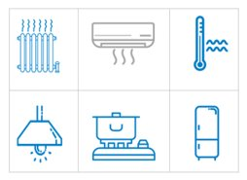
Activity 8: Module 2: Developing Policy Relevant Indicators for the Residential Sector: Assessment Test
Module 2: Assessment Test

1. In the context of the residential sector, understanding how various factors impact energy consumption is essential to determine where the largest potential to reduce energy consumption lies.
True
False

2. Which are the six main end uses in the residential sector:
Space heating
Water heating
Water cooling
Electric appliances
Cleaning
Cooking
Space cooling
Commuting from home to work
Lighting

3. Countries usually prioritise the development of indicators for end uses where large energy consumption is concentrated. Match the indicators according to the country specific policy objectives:
Reduction in the use of fossil fuels: Indicators for space heating and water heating
Reduction of electricity use: Indicators for appliances, lighting or space cooling

4. How detailed should indicators be to develop meaningful energy efficiency policies? Choose the important considerations for policy makers to bear in mind.
The recommended level of disaggregation for large energy-using appliances, such as refrigerators, is at the individual appliance level
Climate and consumer preferences are the most important factors to consider when developing indicators for space heating
Further disaggregation of level 1 indicators may be needed if the building stock in the country is very diverse
Usually energy consumption of urban population in developing countries is more energy intense than consumption of rural population
Residential energy consumption per capita provides general insights on the evolution of the sector, but does not account for the numerous factors and driving forces that influence it

5. Decomposition analysis can be performed to explain the driving forces behind observed changes in energy consumption. Match the structural changes (captured in a decomposition analysis) to the energy end-uses they may have an impact on:
Space heating
Cooking
Appliances
6. Energy consumed for cooking per occupied dwelling (level 2 indicator) provides important insights on the level of cooking efficiency in countries where the energy sources for cooking are diverse, and less so in countries where the energy source is predominantly biomass:
False

7. Energy efficiency indicators frameworks need to be supplemented by additional information, most notably with regard to:
Consumer preferences
Climate change
Political stability
Market developments
Technological innovation

