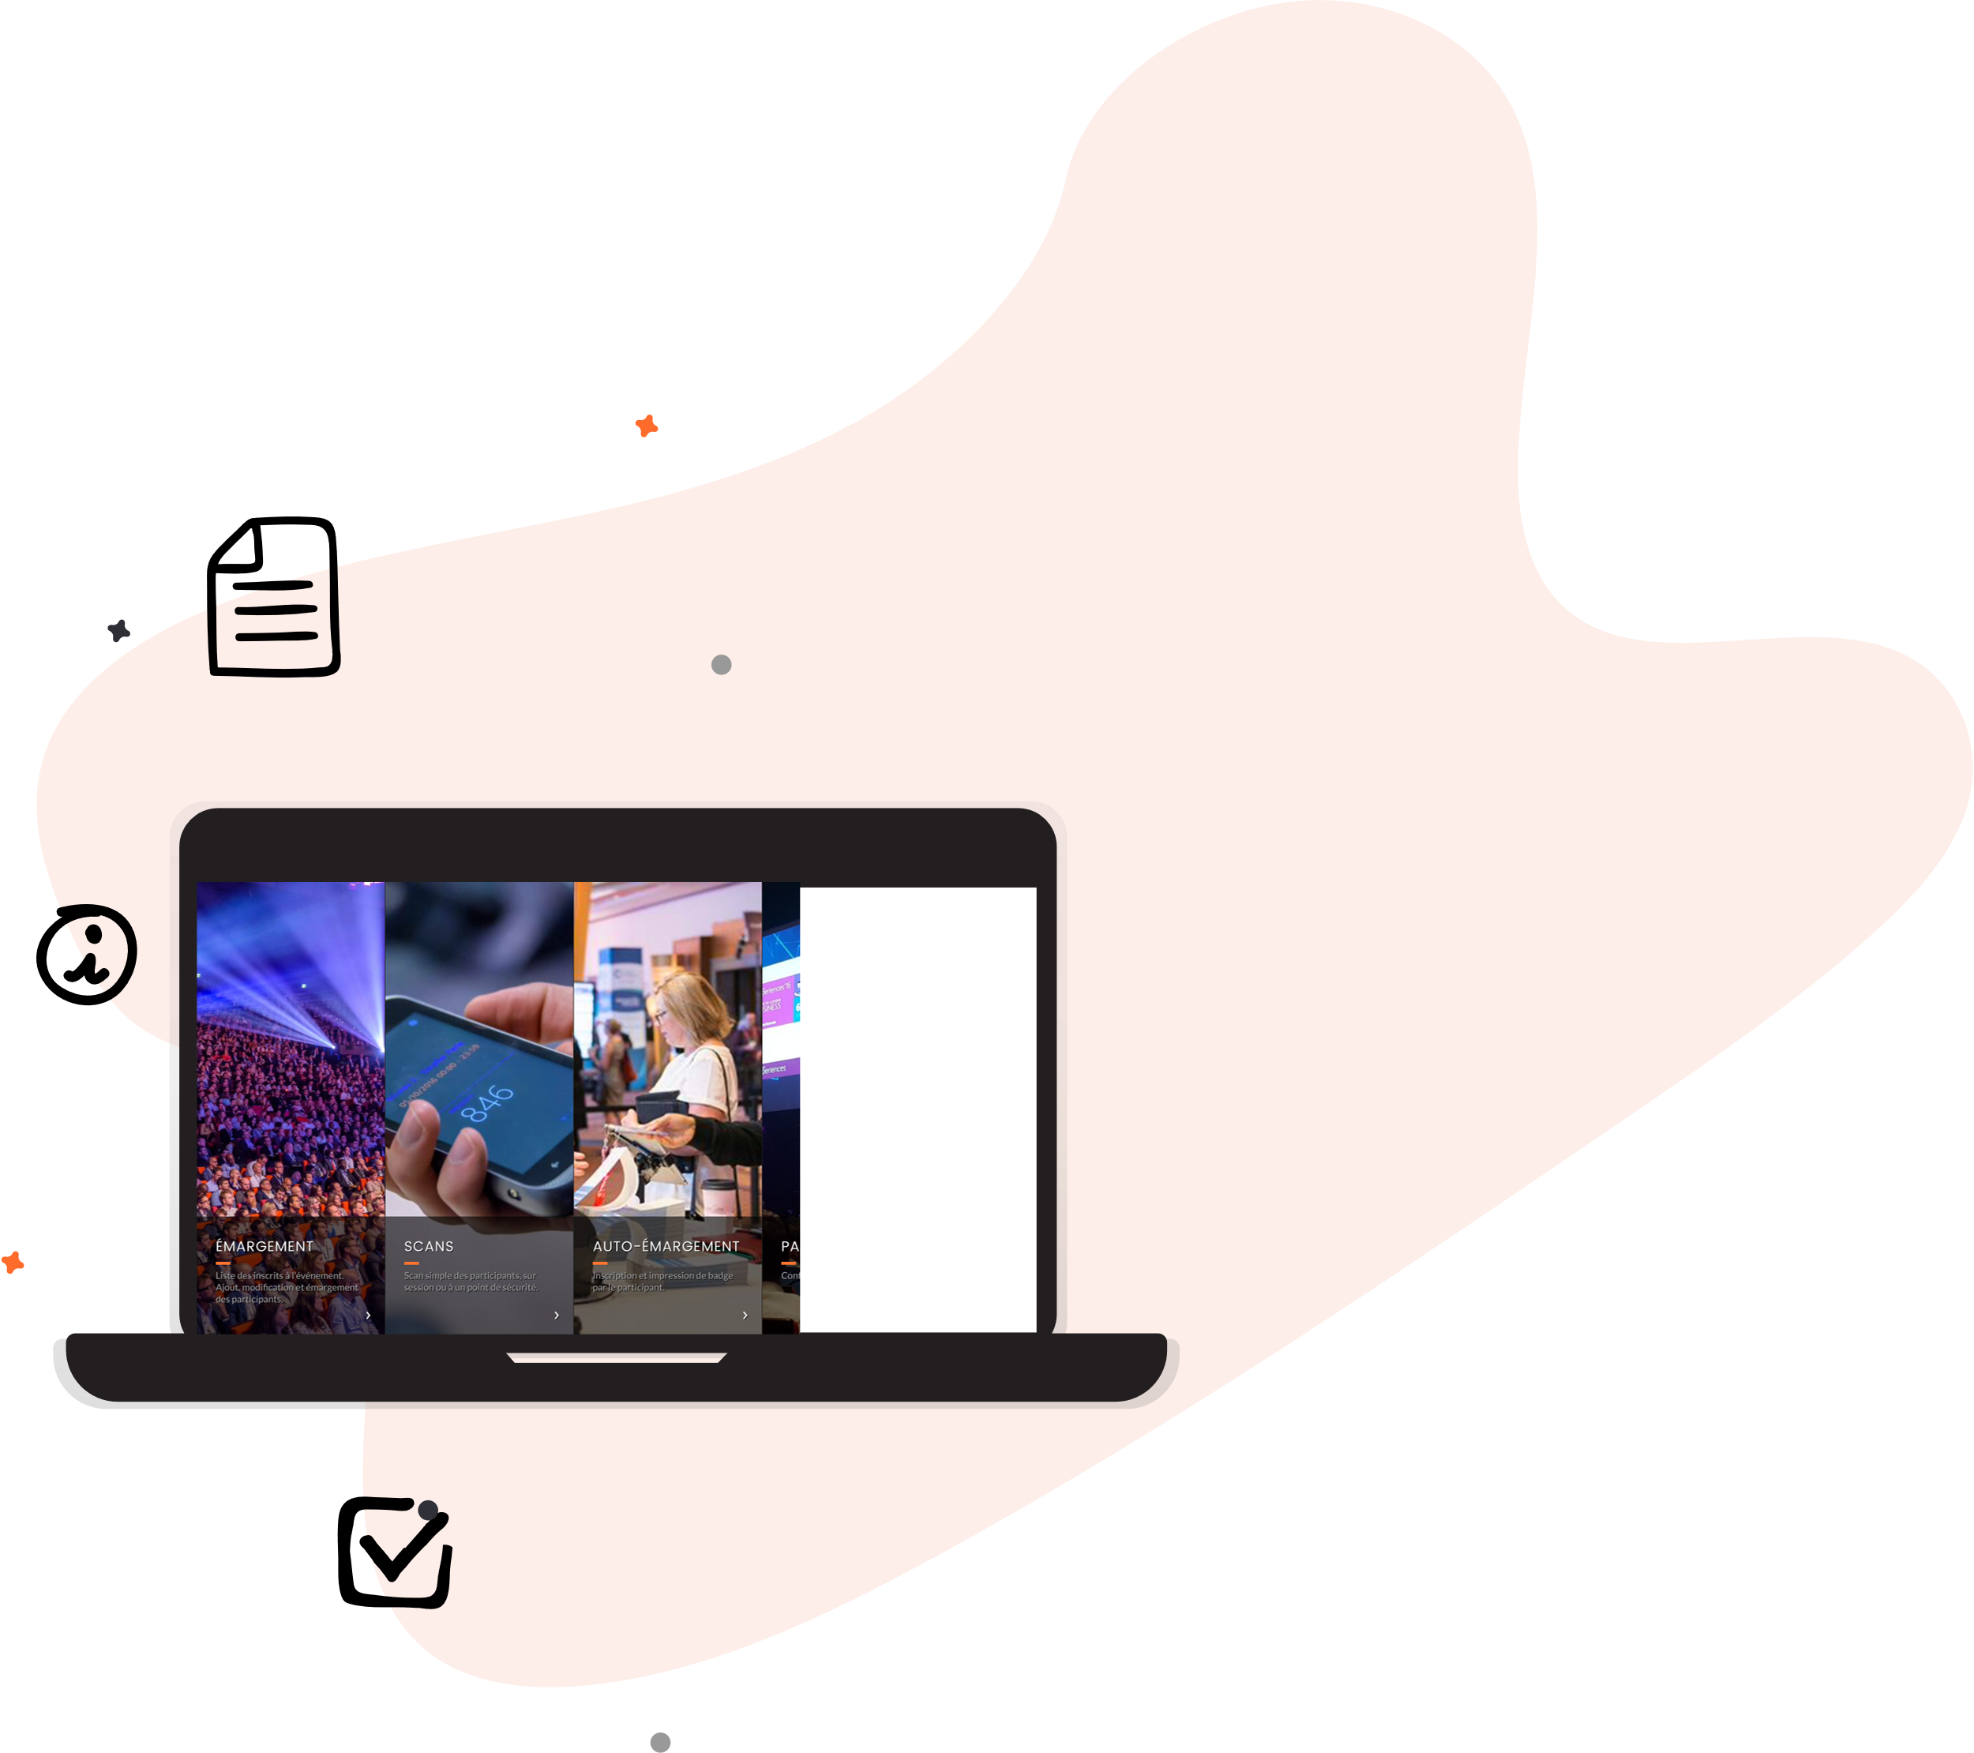
LEADS SCANNING

Step by step explanation

Leads scan with inwink Leadgen application
1. Go on your smartphone’s App Store or Play Store. Search for inwink LeadGen application and install it.
2. Open the app and click on Add an event.
3. Scan your partner QR code so the application recognize the event
4. Click on the event name.
5. Log in with your credentials.
6. Click on the Scan button on the bottom.
7. Scan the QR code of the participant and add a comment if needed.*
*This is an optional field allowing you to add contextual comments of the leads you are speaking with.

8. Click on Validate to capture lead scan.
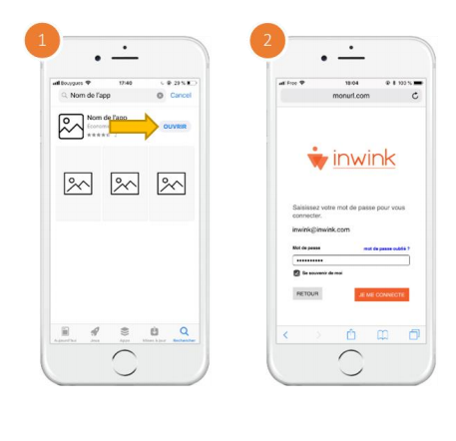

Retrieve the list of scan
You can retrieve the list of scanned participants from the application by clicking on “Exporter” or by connecting to your partner space via your computer.
Note : If you have the “Administrator” status on your company’s partner space, you can retrieve all the list of participants scanned by tour team.
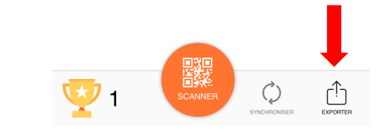

Personalise your scan form
Once you scanned a participant, a text box appears to add a comment. This allows you to add contextual information to the lead you scanned.
To personalise what appears after a scan, from a laptop, follow the instructions below:
- Go back on your Partner space
- Click on the menu Scan on the left
- Click on the button Edit form
- By clicking on Add, you can choose the type of field to add, its label, and values for choices list
Form personalisation allows you to add details about your discussions and your lead’s scan.

Lead scan training
You can try and scan the QR code below.

Use case

When clicking on the "Add a new event" button, nothing happens -> check that you have authorized access to the camera on the inwink Leadgen application in the settings of your phone.

If you have already used the inwink Leadgen application on another event, to connect to the right event you have to uninstall and install the application again.

After logging in, a message "You are not authorized to scan on this event, please request access to this feature" appears -> You are not a member of the partner team. Make sure you are logging in with the correct email address that your administrator added you with. You can ask your administrator to add you to the team from a computer in the partner area of the event site.

